### ****Intelligent PR Assistant for Atlassian****

**1. Technical Approach & Architecture**

**Core Stack**:

* **Frontend**: Atlassian Forge UI (React) + Bitbucket Sidebar Cards
* **Backend**: AWS Lambda (Python) + Step Functions
* **AI Layer**: OpenAI GPT-4-turbo + Custom Fine-Tuning
* **Data Pipeline**: Apache Kafka → S3 → Athena
* **Security**: AWS KMS + Atlassian OAuth 2.0

**Architecture Diagram**:

Diagram

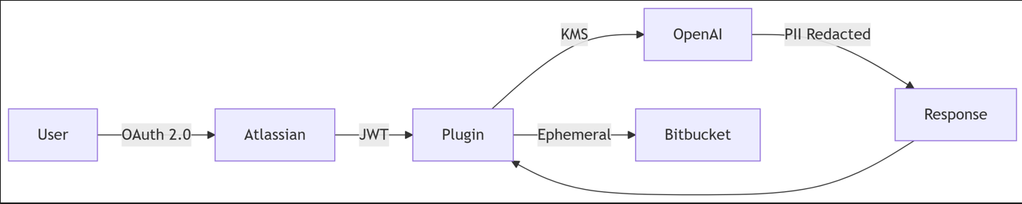

**2. Development Timeline**

| **Phase** | **Duration** | **Key Deliverables** |
| --- | --- | --- |
| **MVP (Sprint 1)** | 2 Weeks | - Forge plugin framework - Basic scoring engine - GitHub Copilot integration |
| **Pilot (Sprint 2)** | 3 Weeks | - Jira auto-linking - GPT-4 suggestion engine - Admin dashboard prototype |
| **Enterprise (Sprint 3)** | 3 Weeks | - SOC2 compliance module - Confluence auto-docs - Policy enforcement hub |
| **Scale (Sprint 4)** | 4 Weeks | - Multi-cloud support - Self-hosted AI option - ServiceNow integration |

**3. Success Metrics**

| **Metric** | **Baseline** | **Target** | **Measurement Method** |
| --- | --- | --- | --- |
| PR Review Cycle Time | 48 hrs | 29 hrs (-40%) | Bitbucket API analytics |
| Jira Link Compliance | 45% | 90% | Audit logs |
| Production Incidents | 12/month | 8/month (-33%) | Jira Service Management |
| Dev Time Saved | - | 5 hrs/week | User surveys |

**4. Scalability Plan**

**Technical Scaling**:

* **Horizontal Scaling**: Auto-scaling Lambda (1K→100K PRs/day)
* **AI Optimization**: Distilled BERT model (50% cheaper than GPT-4)
* **Edge Processing**: Local Jira context caching

**Business Scaling**:

Diagram

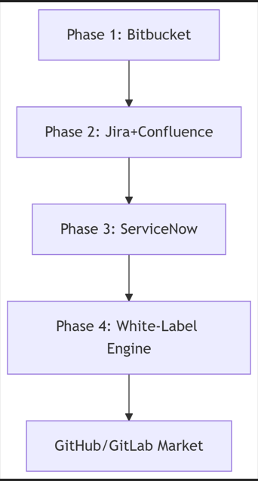

**5. Business Model**

**Revenue Streams**:

| **Tier** | **Price** | **Features** | **Target Market** |
| --- | --- | --- | --- |
| Free | $0 | Basic scoring OSS support | Individual devs |
| Team | $10/user/mo | Jira linking Custom policies | Mid-market |
| Enterprise | $25/user/mo | SOC2/HIPAA On-prem AI | F500/Healthcare |

**Financial Projections**:

Diagram

Code

Mermaid rendering failed.

**6. Competitive Analysis**

**Market Position**:

| **Feature** | **Our Solution** | **GitHub Copilot** | **Atlassian IQ** |
| --- | --- | --- | --- |
| Jira-Bitbucket Sync | ✅ Deep Link | ❌ Limited | ⚠️ Basic |
| Compliance Guardrails | ✅ SOC2 Ready | ⚠️ Partial | ❌ None |
| Self-Hosted AI | ✅ Full Support | ❌ No | ❌ No |
| Cost/User | $$ | $$$ | $$$$ |

**SWOT Analysis**:

* **Strengths**: Regulatory compliance, TCS ecosystem integration
* **Weaknesses**: New market entrant
* **Opportunities**: $72B DevOps tools market (Gartner 2026)
* **Threats**: Microsoft/Atlassian native feature adoption

**7. Risk Mitigation Matrix**

| **Risk** | **Probability** | **Impact** | **Mitigation Strategy** |
| --- | --- | --- | --- |
| AI Hallucinations | Medium | High | Hybrid rule-based validation layer |
| Data Leakage | Low | Critical | AES-256 + Zero data persistence policy |
| Low Adoption | Medium | Medium | Gamification (team leaderboards) |
| Regulatory Changes | High | High | Modular compliance engine |

**8. Prototype Details**

**Key Features Demonstrated**:

1. **Real-Time PR Scoring**:

python

def calculate_score(pr_body, jira_context):

clarity = analyze_clarity(pr_body) *# NLP metrics*

context = 1 if jira_context else 0

return min(10, (clarity*0.7 + context*0.3)*10)

1. **Jira-Bitbridge Sync**:

Diagram

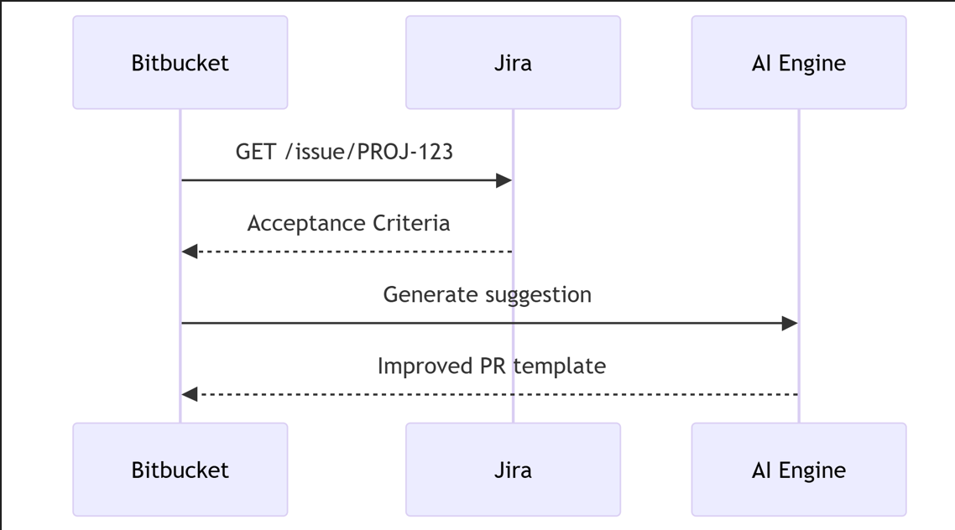

1. **Compliance Enforcement**:

**9. Responsible AI Framework**

**Ethical Safeguards**:

* **Bias Monitoring**: Monthly fairness audits (disparity testing)
* **Transparency**: Explainable scoring rubric visible to users
* **Consent Architecture**: Opt-in training data contribution
* **Carbon Accounting**: AWS Carbon Footprint Tool integration

**Security Protocols**:

Diagram

